
Patient Information Leaflet

Central Medical Centre

Central Medical Centre is a partnership providing NHS Services under an NHS General Medical Services Contract.

42 St Pauls Road
Coventry
Foleshill
CV6 5DF

Telephone No. 02475102795
Website: www.centralmedicalcentre.nhs.uk

Social Media
www.facebook.com/CentralMedicalCentreCoventry
x.com/CMC_Coventry

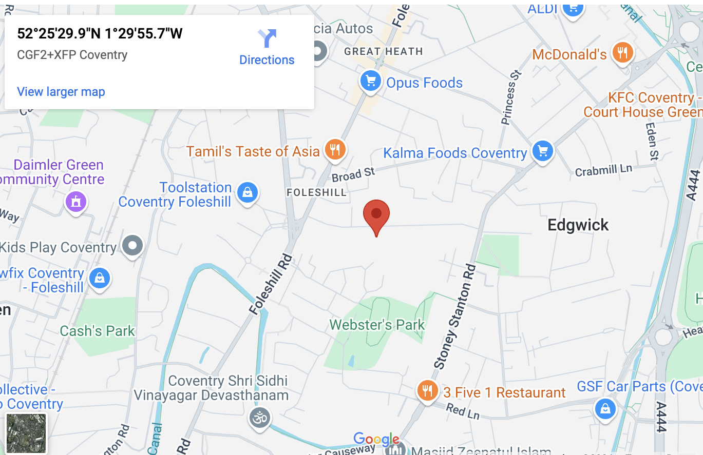
Opening hours
Mon | 8:30 am | 6:30 pm
Tuesday | 8:30 am | 6:30 pm
Wednesday | 8:30 am | 6:30 pm
Thursday | 8:30 am | 1:30 pm
Friday | 8:30 am | 6:30 pm
Saturday | Closed
Sunday | Closed

Services we provide
Along with routine appointments, the practice offers the following services:

- Family planning – All our GPs and the practice nurse offer a full range of family planning services
- Immunisations – The nursing team administers vaccines for both adult and child immunisations. We hold set vaccination clinics, please call for further details. If you are unable to attend these clinics, please discuss with a member of our administrative staff
- Minor surgery – Your GP will advise on minor operations
- Cervical smear testing – For women aged 25 – 65. These tests are undertaken by the nursing team.
- Well-Man and Well-Women clinics – Nurse-led, these clinics are aimed at encouraging a healthy lifestyle for our male and female population
- Chronic disease management – We hold a range of clinics to help our patients to manage their long-term medical problems including asthma, diabetes, hypertension, kidney disease and heart disease.
- Other services – Health checks for adult patients aged 16 to 74 years and 75 years and over are also available especially for those who have not seen a clinician at this practice. Details are available from reception and on the practice website.

We also offer the following clinics and checks: antenatal, baby, post-natal, smoking cessation, counselling for drug and alcohol addiction

From time to time, other services may be available such as raising awareness of a particular disease or condition. We will advertise this information on our website and within the practice.

Teaching practice
The practice is a teaching practice and occasionally trainee GPs may, as part of their training, be required to sit in with their trainer GP during consultations with patients.

You will always be asked if you consent to this prior to your consultation. If you do not consent, the trainee GP will not sit in on your consultation.

How to register at the practice
The quickest way to register at the practice is to use the practice website. You must live within the practice area which is shown on the website. If you are unable to use the website, please contact the practice for information about how to register.

Patients’ rights and responsibilities
When registering, you have a right to express a preference to be seen by a particular GP. This will be recorded on our clinical system and, where possible, you will be allocated appointments with that clinician. All patients will be assigned an accountable GP.

You will also be offered a health check when you join the practice for the first time (see the practice website for a full list of your rights and responsibilities).

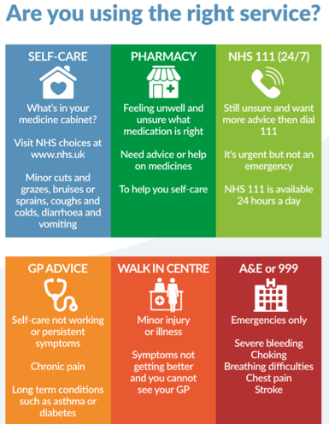

Further information can be sought from www.nhs.uk

Appointments and accessing practice services
To make an appointment to see your GP or any member of our healthcare staff or to access any other of our practice services, please log on to the practice website at [https://www.centralmedicalcentre.nhs.uk]. Should you be unable to access the website, please ring 02475102795 and a member of our administrative staff will be able to assist you.

The practice website contains all the relevant practice information that you are likely to require. It is the quickest way to access the services you may need.

Threats of violence or abuse of our staff
Our staff work hard to provide you with the best possible service. Please treat them with the courtesy and respect they deserve. We operate a zero-tolerance policy and may refuse to provide services to individuals or those accompanying individuals who are violent, threaten violence, commit or threaten to commit a criminal offence

Patient Participation Group
We have an active Patient Participation Group (PPG), ensuring that our patients are involved in decisions about the services provided by the practice.

Further information about our PPG is available online at www.centralmedicalcentre.nhs.uk/about-section/patient-group/
Alternatively, contact Dr A Khan who is the nominated point of contact for all PPG matters.

Patient data
All clinical and administrative staff have an ethical as well as a legal duty to protect patient information from unauthorised disclosure and in accordance with UK GDPR.

The patient privacy notice is available on the practice website.

Comments, suggestions and complaints
If you would like more information about any of the services we provide, please ask a member of staff, telephone or log into the practice website. Details are shown on the front of this leaflet.

Our aim is to give the highest possible standard of service. We would like you to tell us what you think about the service we

Home visits
Home visits are at the discretion of the GPs and are usually for those patients who are housebound or have significant health issues. Should you require a home visit, please use the practice website to request one or contact reception requesting a call-back after logging a call before 10.00 am. A clinician will then telephone you to discuss your request.

Please note that we cannot provide home visits to out-of-area patients

When we are closed
When the practice is closed, if you urgently need medical help or advice and it is life threatening, dial 999. If it is not life-threatening, contact NHS 111 by calling 111 or accessing via www.nhs.uk

The practice team
This practice operates under a GMS partnership agreement and provide services on behalf of the NHS.
Partners
Dr A Khan- GP Principal
Dr Farah Sultana- Managing Partner

Other GPs
Dr Shahnawaz Khan
Dr Tania Salman
Dr Freeha Ahmed

Nurses
Kam Johal
Harleena Dosanjh

Other healthcare staff
Raghbir Sahota- Clinical Pharmacist
Saher Roheel- HCA
Theresa Wallis – Care Co-ordinator
Heather Hine – Care Co-Ordinator
Shannon Warner – Social Prescriber
Susan Smith – Social Prescriber
Donna Rope – Care Co-Ordinator
Mona Mubeen – Social Prescriber
Heena Hussain– Physicians Associate
Josh Antony- Physiotherapist
Amber Winters- Midwife
Healthy lifestyle coach

Practice manager: Farah Sultana

NHS England Contact
Central Medical Centre provides NHS services on behalf of NHS England, PO Box 16738, Redditch, B97 9PT.

Telephone: 0300 311 2233
Email: england.contactus@nhs.net

This leaflet was produced from the Patient Information Leaflet Policy dated Dec 2024.

We also offer the following clinics and checks: antenatal, baby, post-natal, smoking cessation, counselling for drug and alcohol addiction

From time to time, other services may be available such as raising awareness of a particular disease or condition. We will advertise this information on our website and within the practice.

Prescriptions/repeat prescriptions
Your GP will initiate any prescription that they determine you require. Repeat prescriptions can be ordered in the following ways:

- In person – By ticking the required medications on your prescription and placing it in the dedicated box, located at reception.
- By telephone – Please call the practice on 02475102795 before noon
- Online – Please log in and order via our website www.centralmedicalcentre.nhs.uk
Please allow 48 hours for collection (excluding weekends and bank holidays) when ordering repeat prescriptions.

